COCKTAILS

Turkish Espresso Martini 20
Vodka, coffee liquor, triple strained Turkish coffee, cardamom

Spice Market Negroni 23
Seven spices infused gin, ginger & rhubarb liquor,
Campari, vermouth rosso

Rakı Southside 22
Tekirdag Raki, gin, lemon juice, simple syrup, fresh mint

Silk Road Margarita 22
1800 Coconut Tequila, lime juice, agave,
Turkish isot pepper & black salt rim

Kosem Sultan 21
Tequila, Aperol, rose, passionfruit, lime juice, star anise

Galata Tower 23
Turkish tea infused whisky, Aperol, Amaro Montenegro, lime juice

Arı Maya 21
Gin, lemon juice, vanilla infused honey

Anason Spritz 20
Chartreuse, St Germain, lime juice, Brut Varichon & Clerc

NON-ALCOHOL

Pomegranate Dream 12
Turkish pomegranate juice, lime, passionfruit, orange

WINE BY THE GLASS

SPARKLING
20 ‘En Vie’ by Helens Hill, Blanc de Noir, Yarra Valley 13.5
citrus fruits, crunchy red apple, lemon curd, lively and fun

NV Brut, Varichon & Clerc, Burgundy FR (Piccolo 200 ml) 19
scents of orchard fruits, white flowers, elegant and refined

NV Brut, Laurent-Perrier ‘La Cuvee’, Champagne, France 27
toasted nuts, brioche, green apple, lemon pie, fine and persistent

WHITE
20 Isabey Sauvignon Blanc, Menderes, Aegean, Turkey 13
white grapefruit, elderflower, lime zest, herbaceous and fresh

21 Atlas Watervale Riesling, Clare Valley, SA 14
meyer lemon, chamomile, honey suckle, aromatic and tangy

20 Matho, Pinot Grigio “Delle Venezie”, Italy 14
clean bright and lovely aromatic. Pear and a crisp finish

10 McNicol Riesling, Clare Valley, SA 26
citrusy, floral, buttered toast and beeswax, long finish, complex

20 Isabey Chardonnay, Aegean, Turkey 13
nectarine, pineapple, almond skin, tropical and bright

19 Sevilen ‘Premium’ Chardonnay, Menderes, Aegean, Turkey 16
white peach, apple curd, hazelnuts, cinnamon, Layered and complex

WINE BY THE GLASS

ROSE
20 Pasaeli Calkarasi Rose, Denizli Turkey 13
crushed red berries, apple peel, spicy, juicy and refreshing

20 Villa AIX Rose, Maison Breban, Aix-en-Provence, France 16
opaque, elegant and classic

RED
19 Chard Farm River Run, Pinot Noir, Central Otago, NZ 20
raspberry, dark cherry, black tea, juicy fruit with a savoury edge

16 Sevilen Plato Kalecik Karasi, Aegean, Turkey 14
dark fruits, smoked meat, granite, pure fruit with nice grip

19 Sevilen Premium Syrah-Merlot, Aegean, Turkey 15
lifted blue fruits, violets, cracked pepper, spicy deliciousness

18 Sevilen Tepe Cab Sauvingnon Parcel No.IX, Denizli, Turkey 13
red fruits, smoky note of herbs, round, well balanced, long finale

17 900 Cabernet Sauvignon, Aydin, Turkey 19
red currants, dark raspberry, bell pepper, polished and fresh

16 Centum Syrah, Guney Denizli, Turkey 20
purple fruits, tapenade, spicy, soft and classy

WINE SPECIALS

(Limited Stock)

WHITE

18 Danese Delle Venezie Pinot Grigio, Italy 60
Crisp with delicate flavors with hints of peach, melon, pear and lime.

RED

18 El Gringo Tempranillo, VDT Castilla, Spain 55
It has alluring aromas and flavours of black cherries, roasted coffee bean and hints of milk chocolate. Full-bodied with a long, velvety finish.
17 Dunsborough Hills, Cab Sauvignon, Margaret River, WA 60
Blackcurrant, cassis and black cherry. Some background oak and fine, ripe tannins add dept and length.
19 Pasaeli 6N, Karasakiz- Merlot, North Mount Kaz, Turkey 55
Grown in a single vineyard at an alituttude of 550m, it's fermented with native yeast only. Light to medium bodied, characteristically Karasakiz, with distinctive aroma of red cherry, cranberry and dried figs.
16 Saint George Aghiorghitiko Nemea, Greece 50
It is a medium bodied wine with graceful texture, balanced acidity and very ripe elegant tannins. The finish is moderately long, full of red fruits with a touch of sweet vanilla and black pepper.

BEERS & CIDER
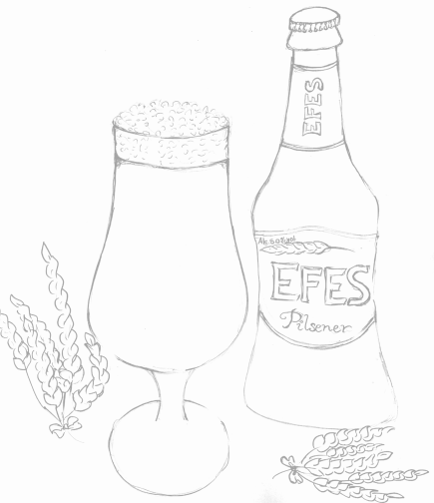
EFES Pilsener, Turkey 11
4 Pines Kolsch Ale, NSW 12
Stone & Wood Golden Ale, NSW 12
Murray’s Angry Man Pale Ale, NSW 12
Cooper’s Premium Light, SA 12
Barossa Apple Cider, SA 10

SOFT DRINKS 5
Uludag Gazoz – Turkish Lemonade
Uludag Portakal Gazoz – Orange Flavoured Turkish Lemonade
Juices (Pomegrate, Sour Cherry)
Coke | Coke Zero
Ginger Ale | Tonic Water
Ayran – Traditional Salty Yogurt Drink
Shalgam – Fermented Black Carrot Juice

RAKI Lion’s milk
Anise flavoured aperitif produced by distilling suma grapes in traditional copper alembics. In Turkey, Raki is the unofficial 'national drink', traditionally drunk mixed with water; the dilution causes this alcoholic drink to turn a milky-white colour, and possibly because of its colour, is popularly called “aslan sütü”, meaning “lion's milk”.

 | Glass | 350ml | 700ml
YENI RAKI  Traditional and classic | 9 | 60 | 120
TEKIRDAG CLASSIC  Admired Thracian aniseed and grapes | 11 | 65 | 130
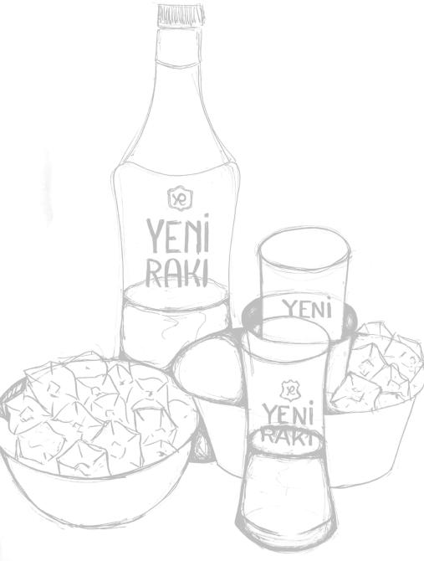  TEKIRDAG NO:10  Fresh grapes in old alembic distillation | 15 |  | 150
YENI RAKI ALA  A premium expression from Yeni Raki, made with sun-dried grapes, which are mixed with high-quality aniseed and then triple distilled. |  |  | 160
YENI MASTER BLEND  Signature blend of Yeni Raki |  |  | 165
Beyaz Peynir & Kavun – Barrel Aged feta and melon best enjoyed with Raki |  |  | 15

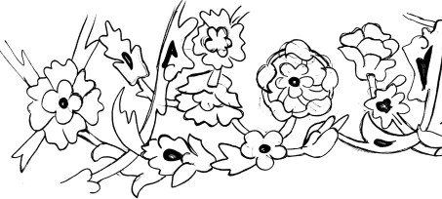
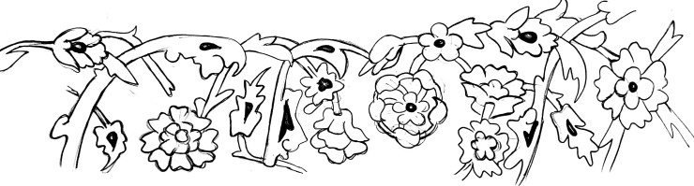
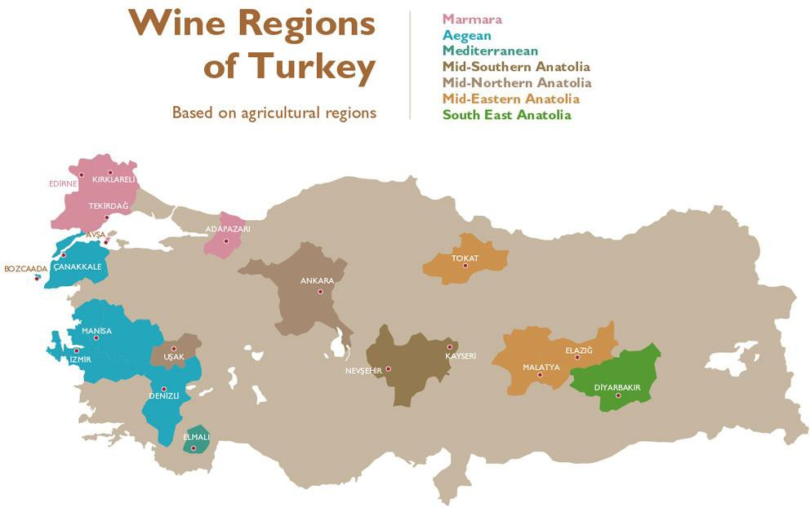
.

Thrace and Marmara: They are located south of Bulgaria and southeast of Greece, bordering the Black Sea, Marmara Sea and the Aegean Sea. They enjoy a typical Mediterranean climate. The Thrace and Marmara wine regions produce about 13.6% of the wine in Turkey.
Aegean region: it is located in the western part of Turkey facing the Aegean Sea and Greek Islands. The climate is Mediterranean near the coast and continental on the Anatolian Plateau. The Aegean wine region produces about 52.7% of the wine in Turkey.
Mediterranean region: it is located in the south part of Turkey facing the Mediterranean Sea. The Mediterranean wine region produces only 0.2% of the wine in Turkey.
Anatolia region: In Anatolia, the climate is continental with hot and arid summers and cold winters. Sub-regions are located in the South-East near Iraq and Syria, in the East, close to the Black Sea, in the North, near Ankara, and in Cappadocia, in the centre of the country. Anatolia produces about 33.5% of the wine in Turkey.

SPARKLING WINES
NV Brut, Varichon & Clerc, Burgundy, France 65
20, ‘En Vie’ by Helens Hill, Blanc de Noir, Yarra Valley 65
NV Laurent-Perrier ‘La Cuvee’ Brut (375ml), Champagne 90
NV Lanson Pere et Fils, Brut, Champagne, France 150
08 Laurent-Perrier Millesime Brut, Champagne, France 275

ROSE

19 Majestic Grenache & Kalecik Karasi, Aegean, Turkey 58
20 Pasaeli Calkarasi Rose, Denizli, Turkey 60
19 Saint & Scholar Pinot Noir Rose, Adelaide Hills, SA 75
20 Villa AIX Coteaux, Maison Breban, France 80

Bright – WHITE WINE
20 Isabey Sauvignon Blanc, Menderes, Aegean, Turkey 60
18 Narince, Navitus Sevilen, Tokat, Anatolia, Turkey 54
19 Majestik Sauvignon Blanc, Menderes, Aegean, Turkey 58
21 Atlas Watervale Riesling, Clare Valley 68
19 Margan, Semillon ‘Fordwich Hill’, Hunter Valley NSW 84
20 Nova Vita, Pinot Gris, ‘Firebird’ Adeleide Hills, SA 65
19 Astrolabe, Sauvgnon Blanc, Awatere Valley, New Zealand 90
19 Domaine Alain Gautheron Chablis Fleys, France 140

Textural – WHITE WINE
16 Sevilen Isabey Chardonnay, Izmir, Turkey 60
19 Sevilen 900 Fume Blanc, Denizli, Turkey 78
19 Sevilen ‘Premium’ Chardonnay, Menderes, Aegean, Turkey 79
19 Chamlija “Felix Culpa” Chardonnay, Kirklareli, Turkey 105
19 Riesling Gustave Lorentz Reserve, Alsace, France (Organic) 89
19 Gotas del Mar Albariño, Rias Baixas, Spain, 88
18 Tellurian, Marsanne, Heathcote VIC 76
20 Flametree, Chardonnay, Margaret River, WA 80
19 Greystone, Sauvignon Blanc (Barrel Ferment) 74
Waipara, NZ, (Organic)
13 Semillon, Tyrrell's 'Vat 1’, Hunter Valley, NSW 200
14 Peter Lehmann “Wigan” Riesling, Eden Valley 110
19 Paringa Estate, Chardonnay, Mornington Peninsula, VIC 90
19 Howard Park, Chardonnay, Margaret River, WA 145
18 Domaine Georges Vernay ‘Le Pied de Samson’ Viognier, 195
Rhone Valley, France
16 Leeuwin Estate ‘Art Series’, Chardonnay, Margaret River, WA 300

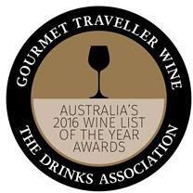
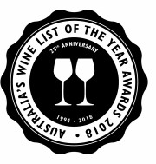
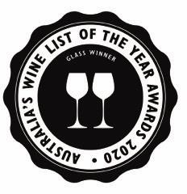
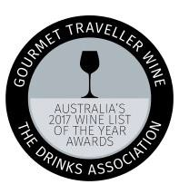
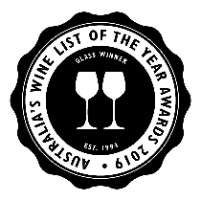

2016 TO 2020 Gourmet Wine list of the year awards One Goble

Juicy – RED WINE
17 Natvius Kalecik Karasi, Mid-North Anatolia, Turkey 52
17 Vinkara Kalecik Karasi, Ankara, Turkey 82
16 Sevilen Plato Kalecik Karasi, Aegean, Turkey 69
19 Lock & Key, Pinot Noir Tumbarumba NSW 60
19 GSM, Tellurian, Heathcote, VIC (Organic) 75
19 Chard Farm River Run, Pinot Noir, Central Otago, NZ 94
17 Helens Hill ‘Single Clone’ Pinot Noir, Yarra Valley, VIC 118
18 Bream Creek, Pinot Noir, Tasmania 120
18 Margan ‘Ceres Hill’, Barbera, Hunter Valley, NSW 90

Savory – RED WINE
18 Majestik Sevilen, Syrah- Kalecik Karasi, Aydin, Turkey 60
18 Sevilen Parcel No: I Syrah, Izmir, Turkey 62
19 Sevilen Premium Syrah & Merlot, Aegean, Turkey 74
16 Centum, Syrah, South Aegean, Turkey 98
17 Sevilen Plato, Syrah & Öküzgözü, Aegean, Turkey 74
19 Kingston Estate, Shiraz, Clare Valley SA 55
19 Round Two, Merlot, Barossa Valley, SA 58
18 Kaesler, Barbera Barossa Valley, SA 88
18 Pampas ‘Expression’, Malbec, Mendoza, Argentina 72
18 Poggiotondo, Chianti, Tuscany, Italy (Organic) 76
19 Capa Tempranillo, Castilla La Mancha Spain 69
19 Yarra Yering, Pinot Shiraz, Yarra Valley, VIC 110
17 'Sons of Eden ‘Eurus’, Cab Sauvignon, Eden Valley, SA 129
13 Yarra Yering Dry Red No.1 Cab Sav / Merlot/ Malbec/ 250
Pet Ver, Yarra Valley, VIC

Bold – RED WINE

18 Sevilen Parcel No: IX, Cabernet Sauvignon, Izmir, Turkey 60
18 Sevilen Parcel No: II, Merlot, Izmir Turkey 58
17 ‘900’ Cabernet Sauvignon, Guney, Aegean Turkey 90
18 Chamlija Kara Sevda, Papazkarasi, Trakya, Turkey 105
19 ‘The Wark Family’, Shiraz, Stonewell (Barossa), SA 78
18 Teusner ‘The G’ Grenache, Barossa, SA 86
19 Paxton Grenache, McLaren Vale, SA 90
18 Majella Estate, Cabernet Sauvignon, Coonawarra, SA 110
14 Teusner ‘Dr. Frank’s’, (Petite Syrah), Barossa Valley, SA 140
13 Geoff Merrill Reserve, Shiraz, McLaren Vale, SA 165

 | VODKA
Vodka One | Australia | 10
Belvedere | Poland | 12
Grey Goose | France | 14
 | GIN
Tanqueray | England | 10
Hendrick’s | Scotland | 14
Monkey 47 | Germany | 20
 | RUM
Ron Zacapa | Guatemala | 14
Bacardi Carta Blanc | Cuba | 10
Flor de Cana 7 Anos | Nicaragua | 14
Plantation Pineapple | France | 14
Sailor Jerry, Spiced | Scotland | 12
 | TEQUILA
Jose Cuervo gold | Mexico | 10
El patron | Mexico | 12
Skelly %100 Agave | Mexico | 16
BOURBON / WHISKEY / RYE / SCOTH
Makers mark – Bourbon Kentucky 12
Wild Turkey, Bourbon Kentucky 10
Jameson – Whisky Ireland 12
Johnnie Walker Double Black - Blended Whisky Scotland 12
Woodford Reserve - Rye Whisky Kentucky 12
Mitchters Straight - Rye Whisky Kentucky 18
Monkey Shoulder – Scotch Scotland 10
Glenfiddich 12 YO – Scotch Whisky Scotland 12
Lagavulin 16 – Scotch Whisky Scotland 16
Glen Morangie 10 single malt - Scotch Scotland 14
Glenfiddich 21 YO – Scotch Whisky Scotland 25

